**Practical No. 7**

1. **Using Packet Tracer, create a network with three routers with OSPF and each router associated network will have minimum three PC. Show Connectivity.**

**Step 1: Take 6 PCs**

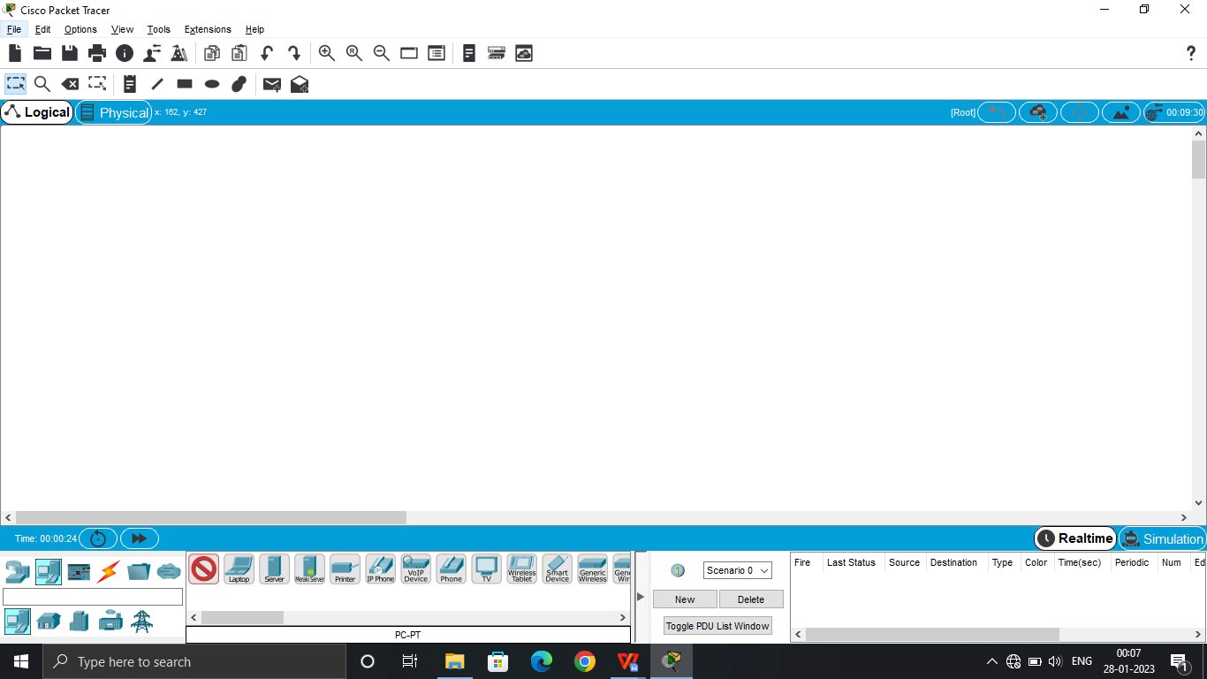

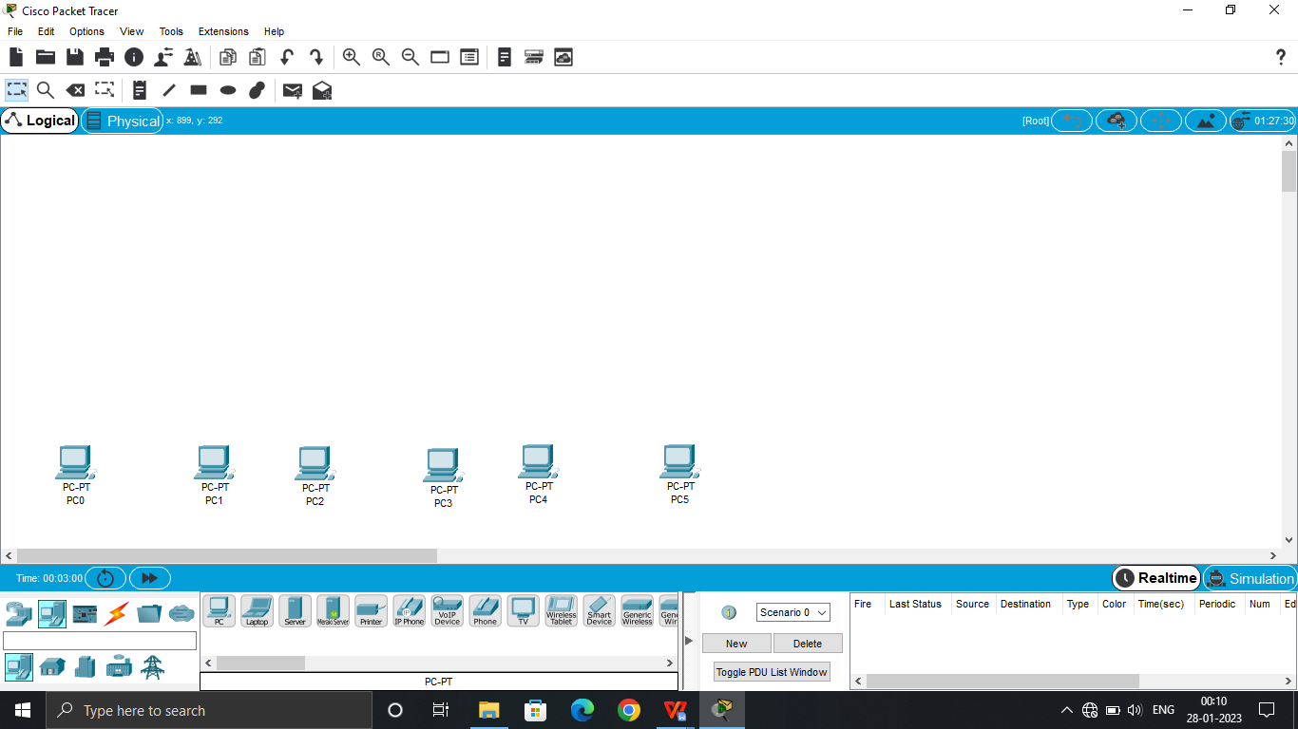

**Step 2: Take 3 routers of name 1841**

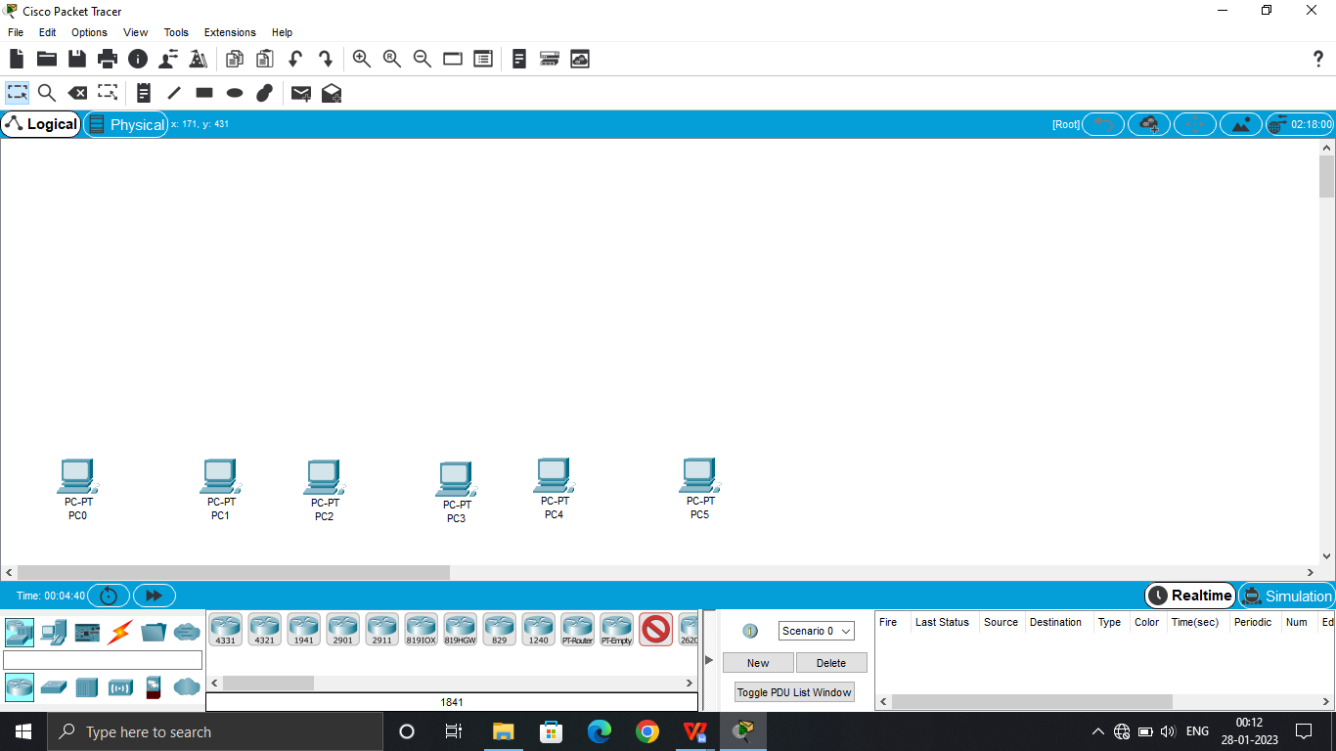

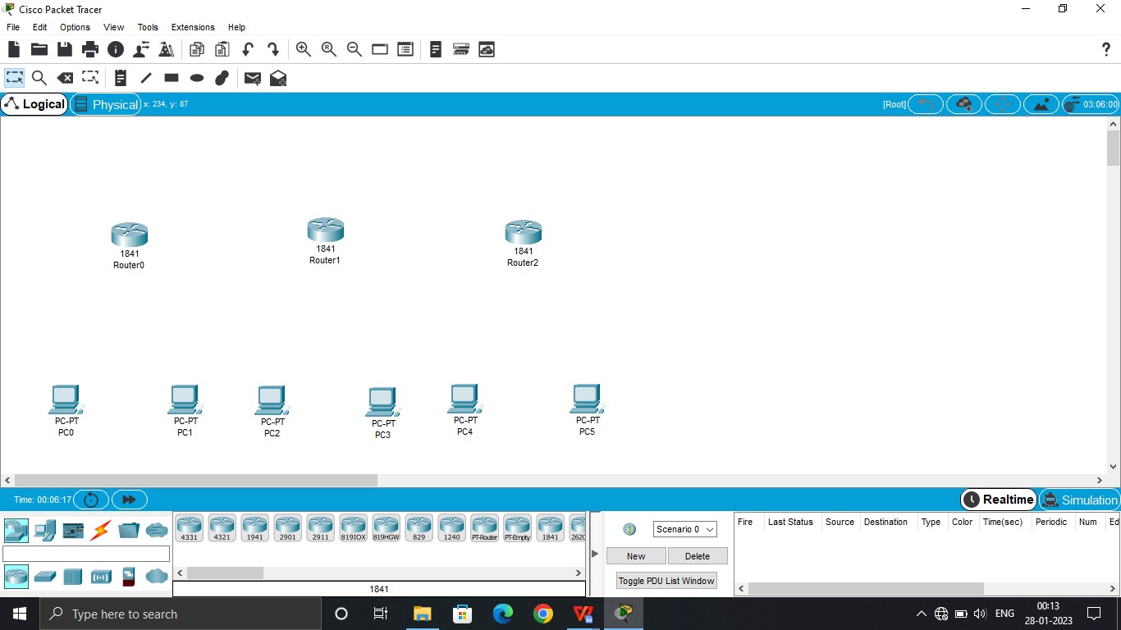

**Step 3: Connect all PCs to their respected Routers via ‘Automatically Choose Connection Type’**

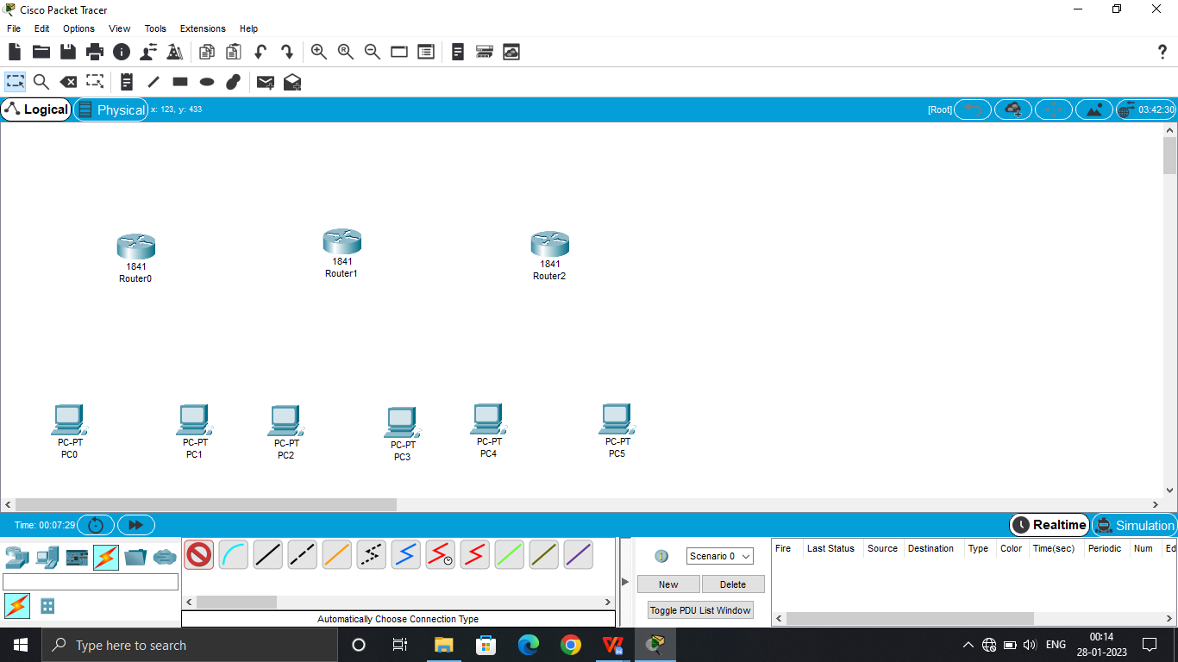

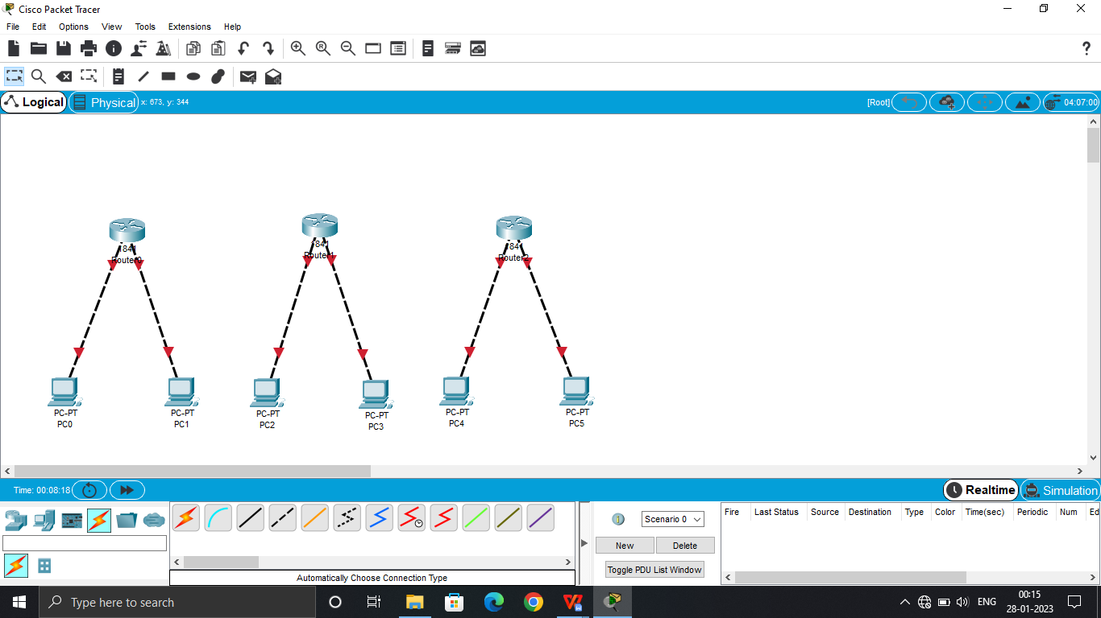

**Step 4: Select Router – Physical – WIC 2T – off Router – add Port – on Router (for all 3 Routers)**

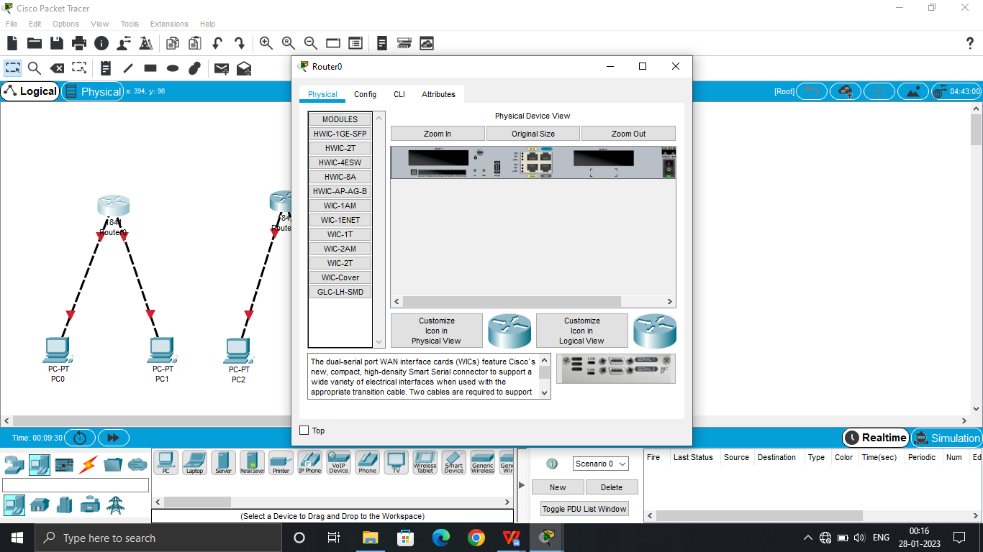

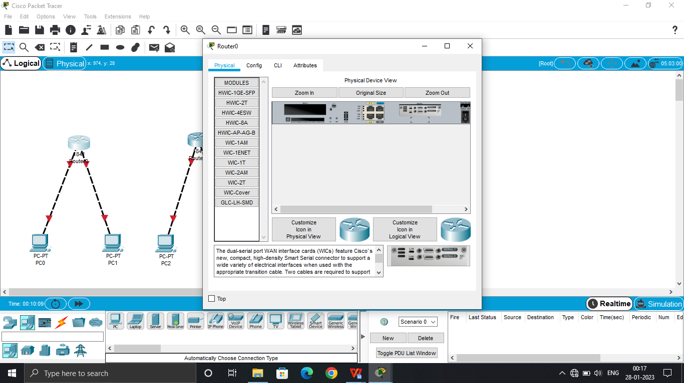

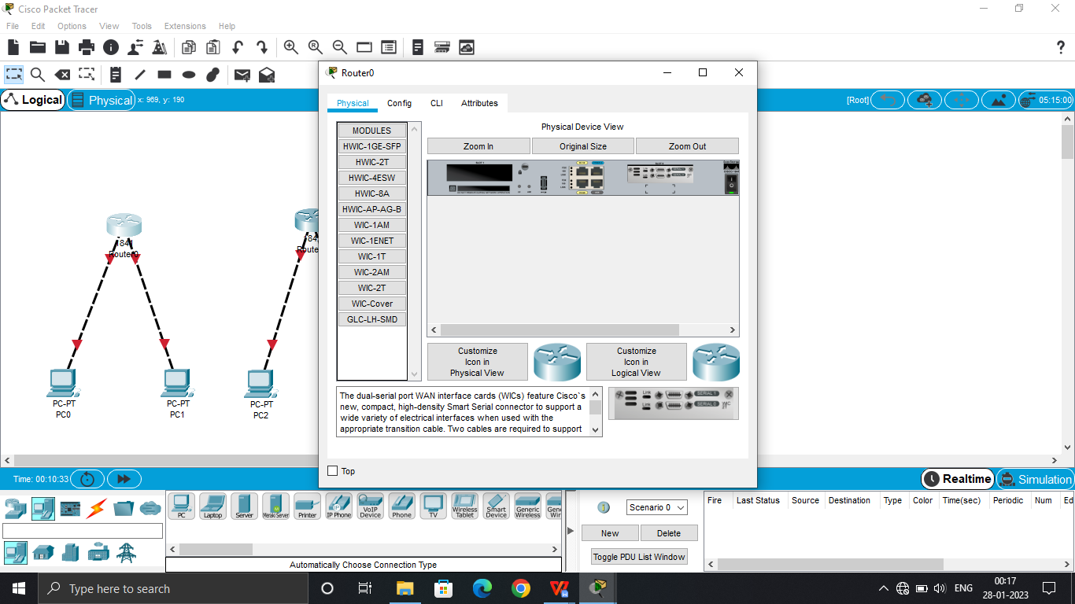

**Step 5: Connect Routers via ‘Automatically Choose Connection Type’**

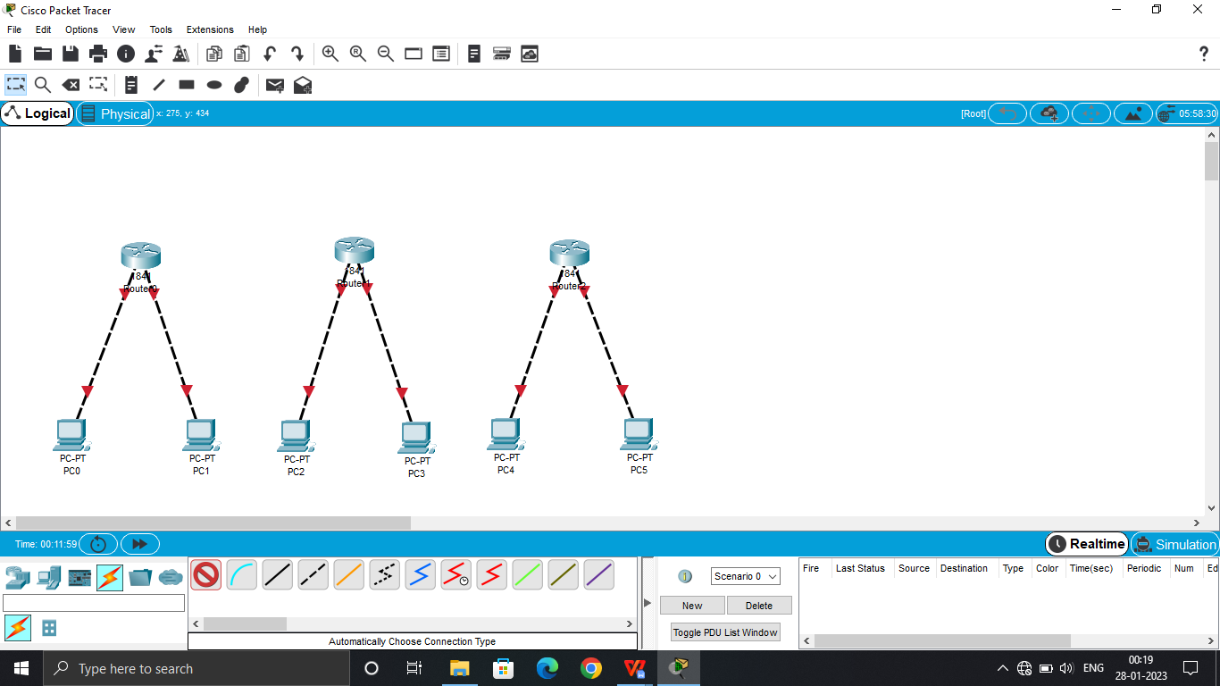

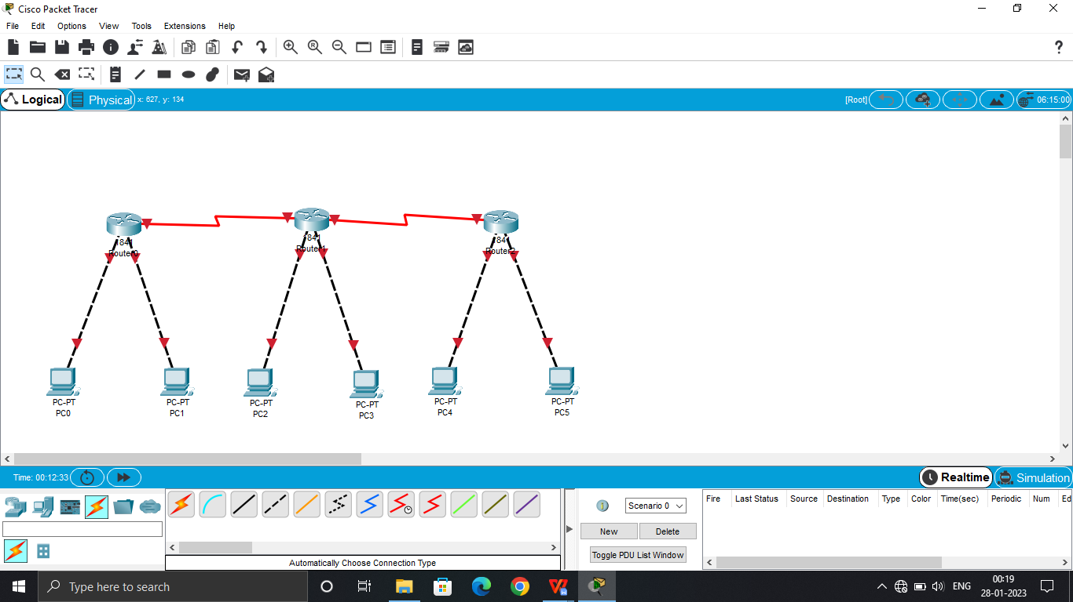

**Step 6: Select Router – Config – Fastethernet 0/0 – give IP as – 192.168.1/3/5.3 – Port Status on (for all 3 Routers)**

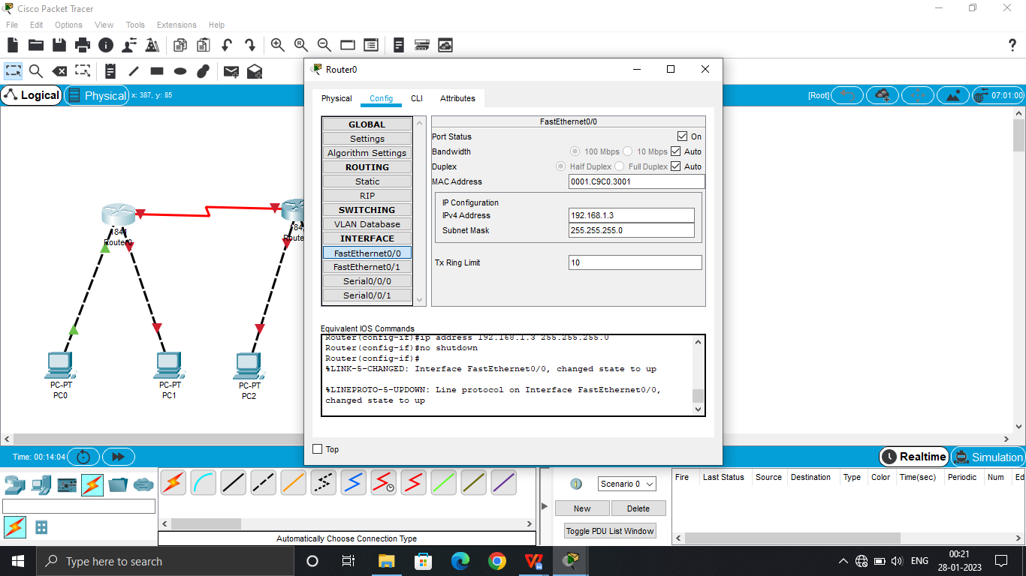

**Step 7: Select Router – Config – Fastethernet 0/0 – give IP as – 192.168.2/4/6.3 – Port Status on (for all 3 Routers)**

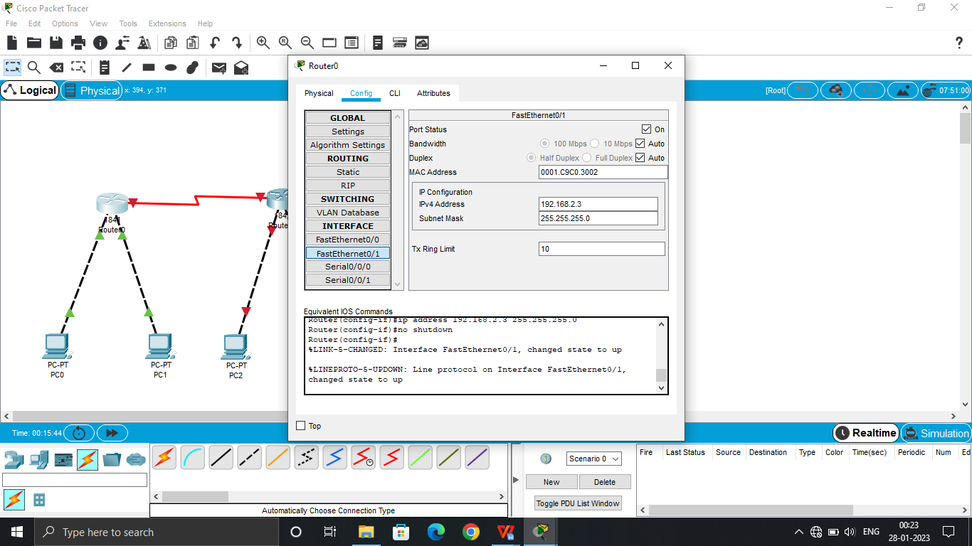

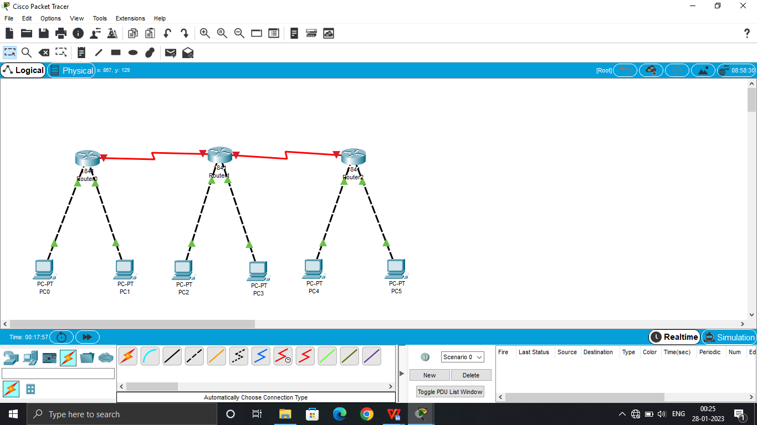

**Step 8: Select PC – Desktop- IP Configuration – IP – 192.168.1/2/3/4/5/6.2 & Default Gateway – 192.168.1/2/3/4/5/6.3 (Router IP) (for all 9 PCs according to their Routers)**

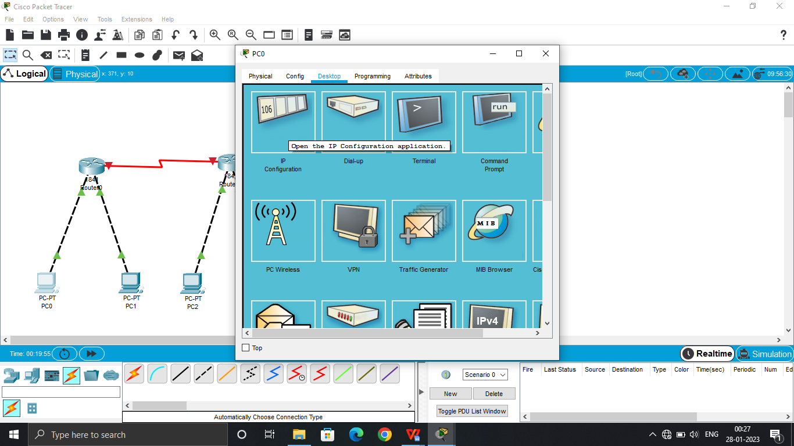

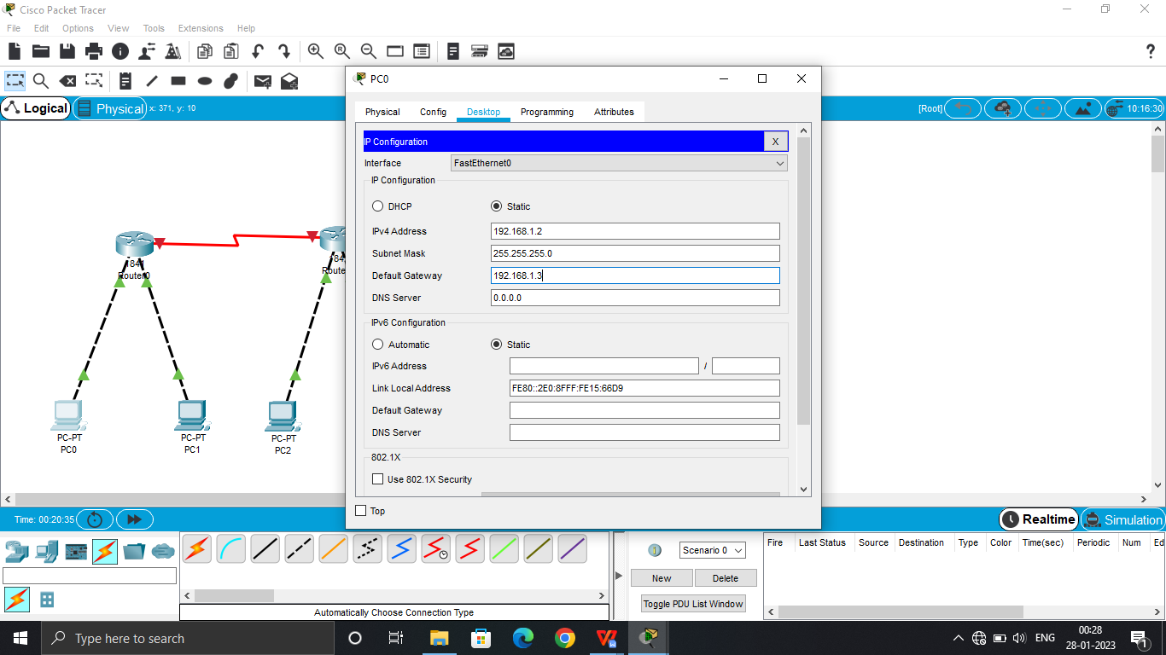

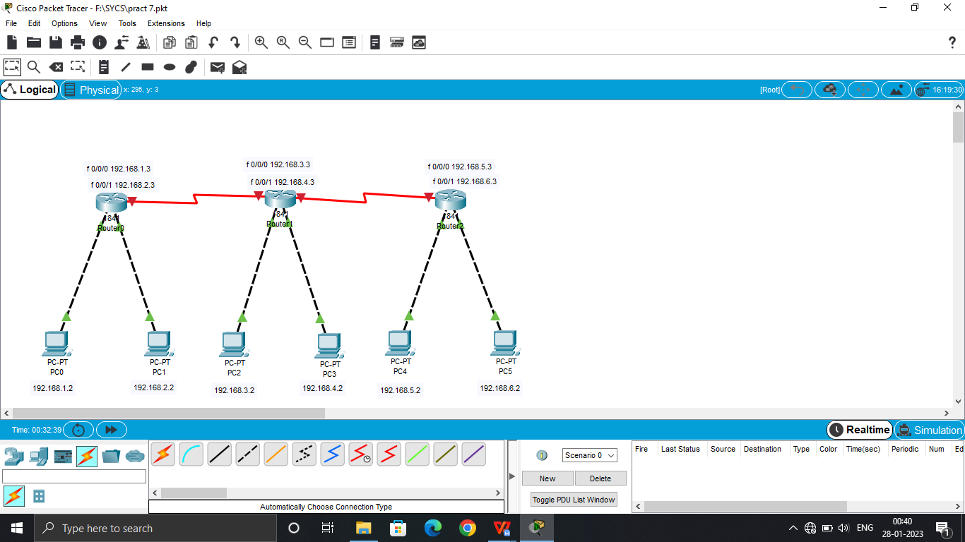

**Step 9: Select first Router – Config – Serial 0/0/0 – set IP – 192.168.7.2 – on the Port**

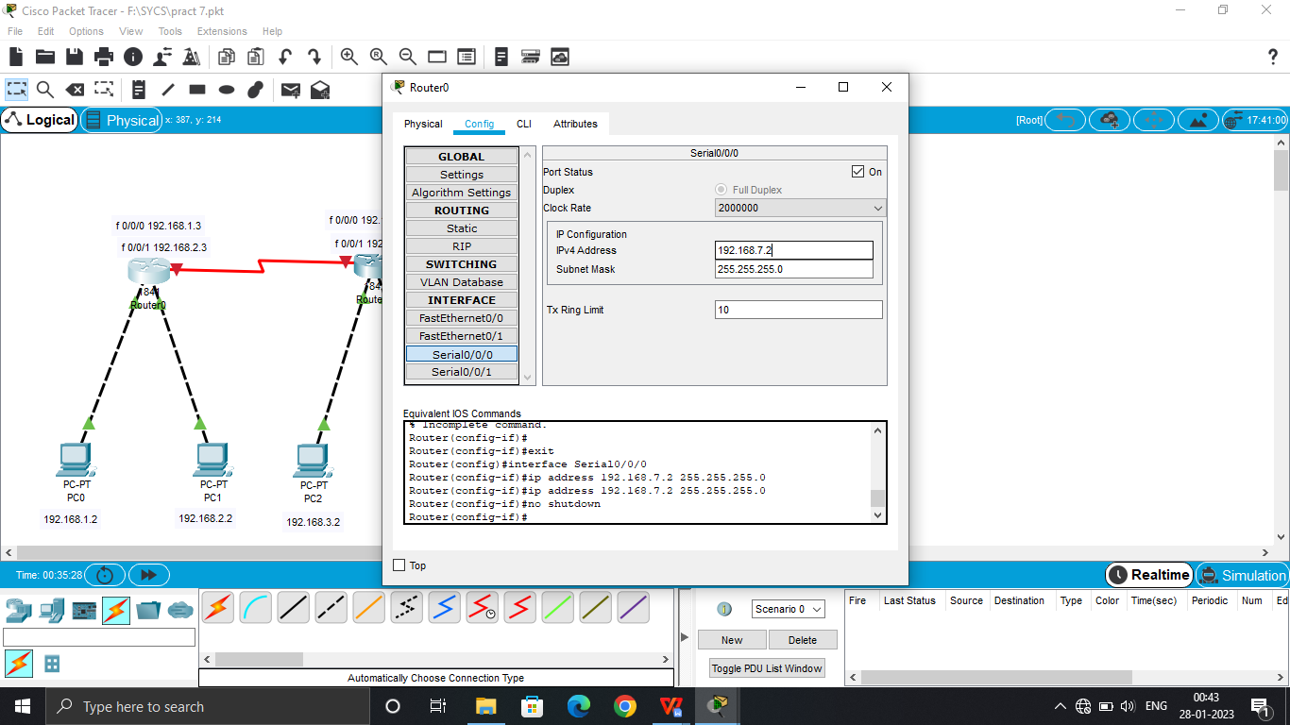

**Step 10: Select second Router – Config – Serial 0 0/0 – set IP – 192.168.7.3 – on the Port**

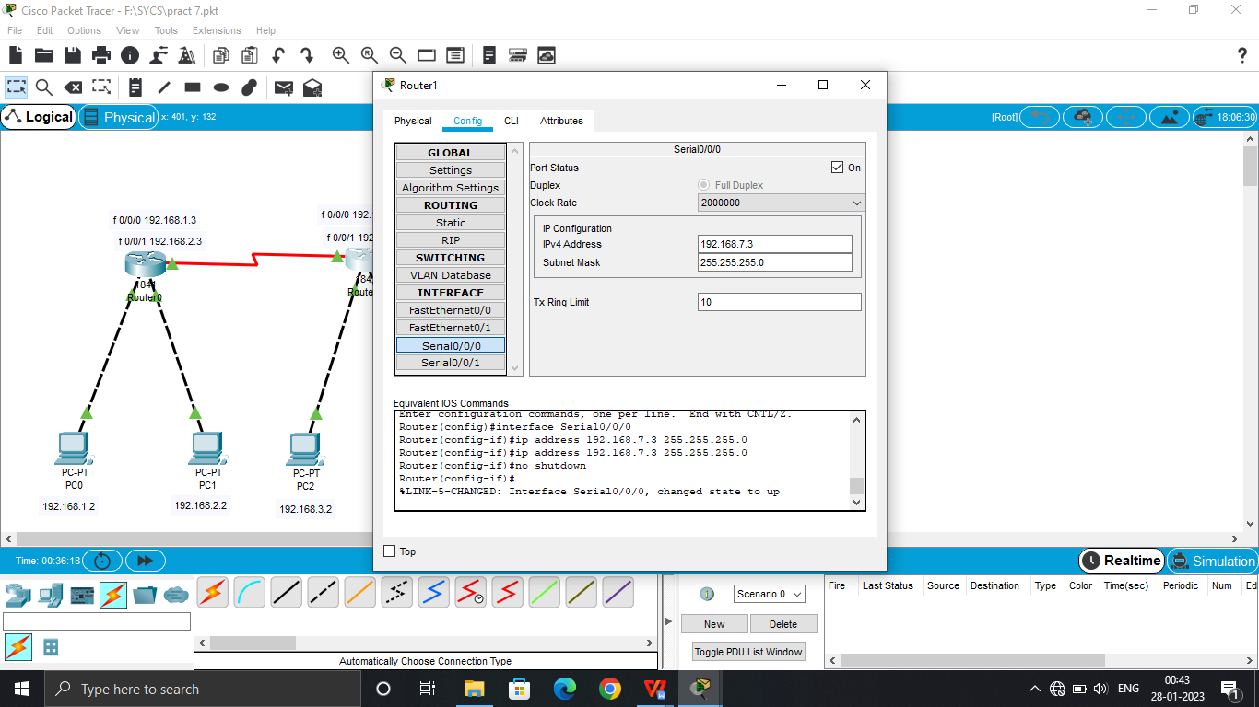

**Step 11: Select second Router – Config – Serial 0/0/1 – set IP – 192.168.8.2 – on the Port**

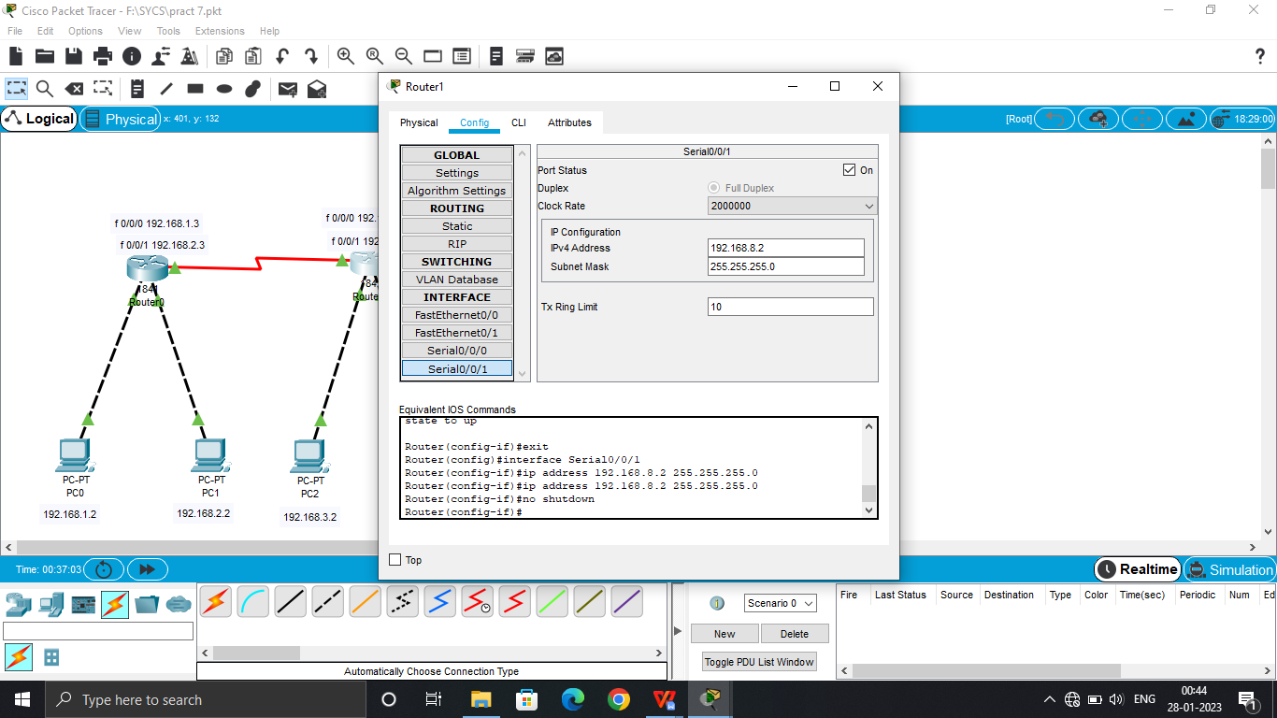

**Step 12: Select third Router – Config – Serial 0/0/0 – set IP – 192.168.8.3 – on the Port**

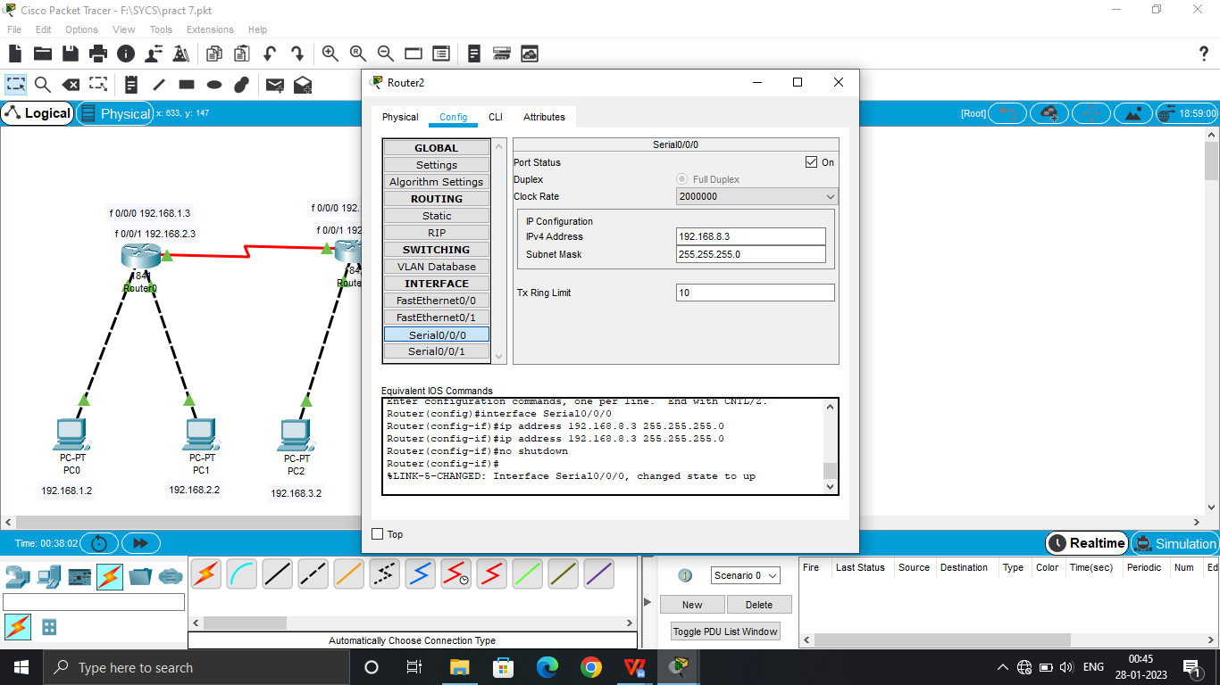

**Step 13: Specify three areas(Area 1, Area 0, Area 2)**

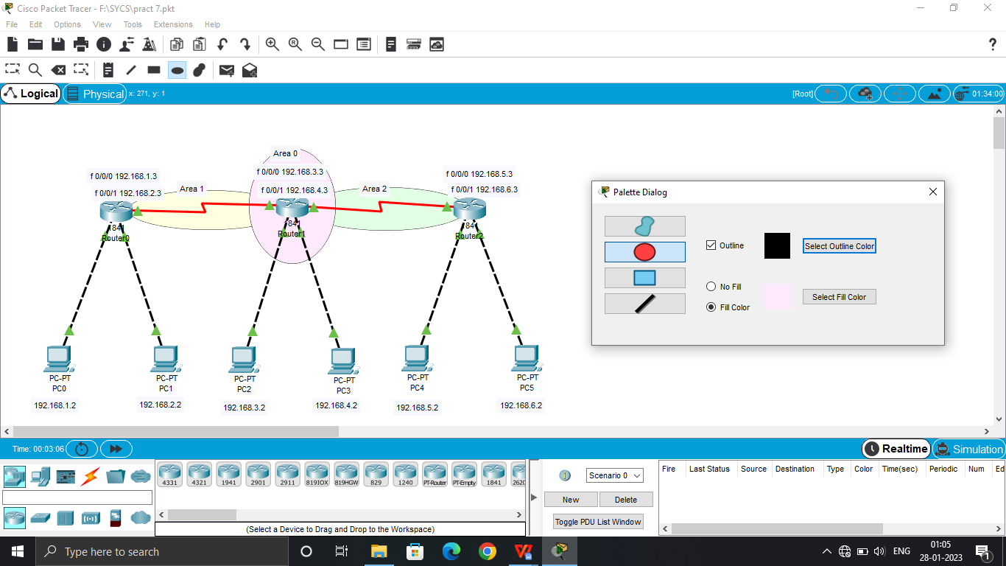

**Step 14: Select First Router – CLI – ‘exit’ command(3 times) – Click Enter – ‘enable’ command – ‘configure terminal’ command – ‘router ospf 1’ command – enter commands ‘network 192.168.1.0 0.0.0.255 area 1’, ‘network 192.168.2.0 0.0.0.255 area 1’, ‘network 192.168.7.0 0.0.0.255 area 0’.**

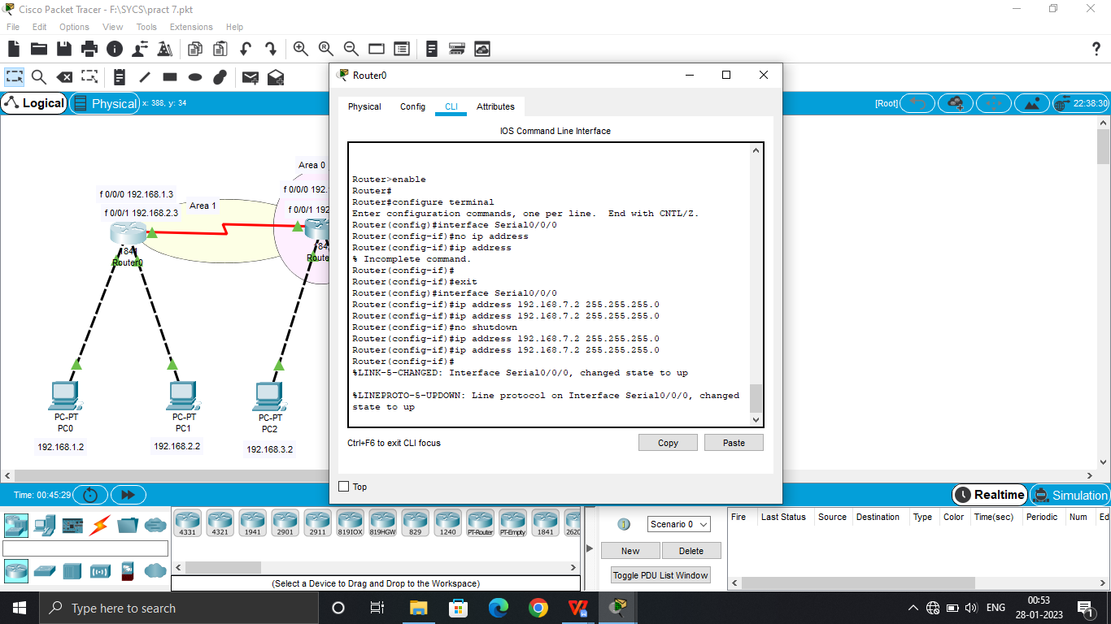

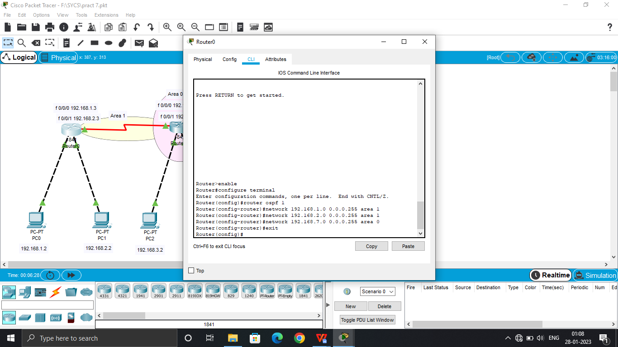

**Step 15: Select Third Router – CLI – ‘exit’ command(3 times) – Click Enter – ‘enable’ command – ‘configure terminal’ command – ‘router ospf 2’ command – enter commands ‘network 192.168.5.0 0.0.0.255 area 2’, ‘network 192.168.6.0 0.0.0.255 area 2’, ‘network 192.168.8.0 0.0.0.255 area 0’**

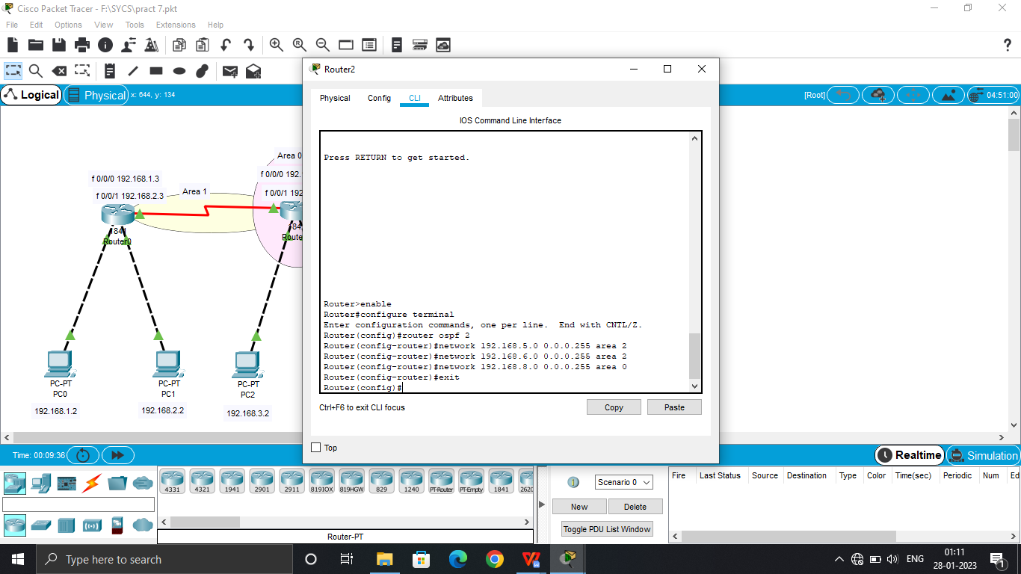

**Step 16: Select Second Router – CLI – ‘exit’ command(3 times) – Click Enter – ‘enable’ command – ‘configure terminal’ command – ‘router ospf 3’ command – enter commands ‘network 192.168.3.0 0.0.0.255 area 0’, ‘network 192.168.4.0 0.0.0.255 area 0’, ‘network 192.168.7.0 0.0.0.255 area 0’, ‘network 192.168.8.0 0.0.0.255 area 0’**

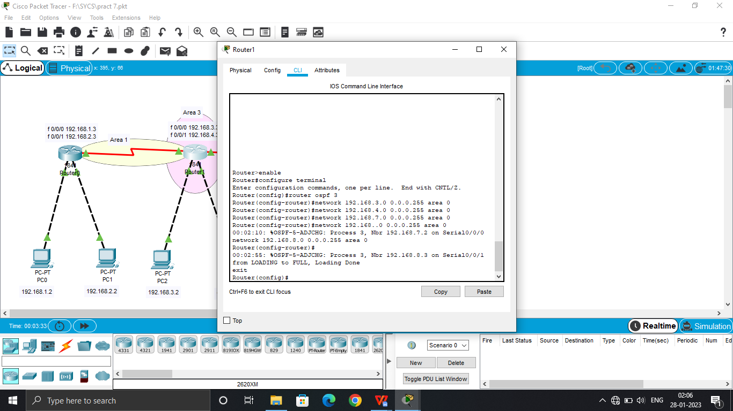

**Step 17: Assign Packets and Check Connection.**

